**Project2 – Expense Express**

**1. Overview**

* Describe the purpose and objectives behind this solution

Expense Express aims to allow users to be able to track their overall spending and be ready for any tax audit.

* Describe the business solution and it’s vision

This is just the minimal viable product but should this app take off, It would have a focus on the Singapore market, mostly at the self-employed market. Additionally, a mobile app would be necessary for growth and future implementations.

* Provide the context in which this solution is needed

Expense Express hopes to help users declutter their wallet as they would be able to digitally store their receipts

* Describe user’s needs and expectations

Users should expect to able to create their own expense and track their expenses with dates. Users also expects to be able to scan their receipts and automatically generate an expense record

* Describe how will the users use the solution  
  Users will login to the website where their expense records will be stored. They will be able to create, edit and delete expenses.
* Describe how the system interacts with other systems

Post-gres SQL will be used for database while nodejs will be the overall framework. HTML and CSS will be used for the frontend alongside bootstrap.

* Other explanations
* Assumptions - *List any assumptions you have about users, technical constraints or business goals (eg: Most users will access this feature from a tablet)*

**2. Technical Documentation**

Technical information:

* ERD



* Site map



* WireFrame

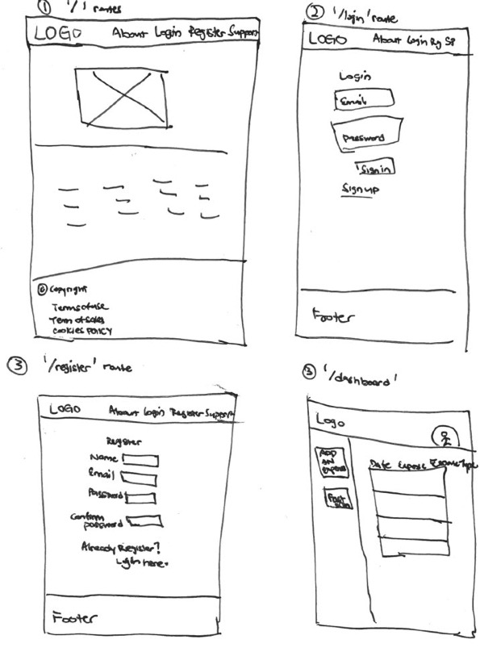

* Routes:

|  |  |  |
| --- | --- | --- |
| / login | app.get |  |
| /register | app.get | app.post |
| /dashboard | app.get | app.post, app.delete |
| /expense | app.get | app.post |
| /expense/:id | app.get | app.post |
| /expense/:id/edit | app.get | app.post |
| /logout | app.delete |  |